How to Access the Teletouch Telewave FTP Server
1632 Pitt River Road, Port Coquitlam, B.C. V3C 1P4
Phone 604 941-5979 Toll-Free 866 528-4005 Fax 604 941-5999
www.teletouchtranscriptionservices.com mailto:teletouch@telus.net

Instructions for FTP Access:

This is an example using WS_FTP. You will use the IP address to access to FTP Site.

The FTP DNS Site Address is ftp.teletouch123.com. Use this address as the Host Name/Address. If you are having difficulty connecting using the DNS address, please try both of our IP addresses before calling for assistance.

ADSL: 64.180.100.71
Cable : 24.80.120.254

Remember to uncheck Passive Transfer. Note the Teletouch system does not support Passive Transfer.

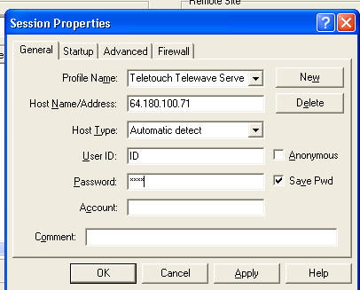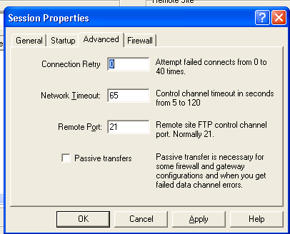

Note: To obtain a copy of WS_FTP go to: http://www.ftpplanet.com/download.htm
To obtain a copy of CuteFTP: http://www.globalscape.com/downloads/cuteftp.asp

Instructions for Internet Explorer:
To access FTP sites through internet explorer
The Telewave site requires a user name and password, you need to include that information in the address. For example:
ftp://userID:password@64.180.100.71/
- To download a file or folder, right-click the item on the page, and then click Copy to Folder.
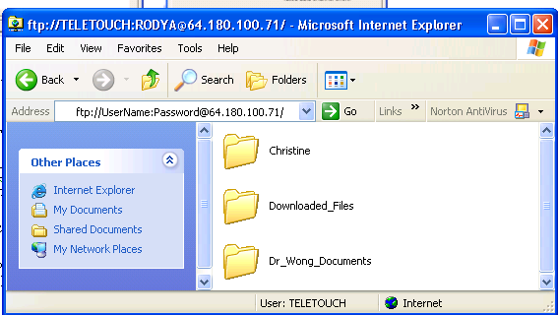

Instructions for Voicewave or the Voicewave Converter

From the Voicewave Recorder or the Converter Main Manu, select File|New|Internet FTPBasket

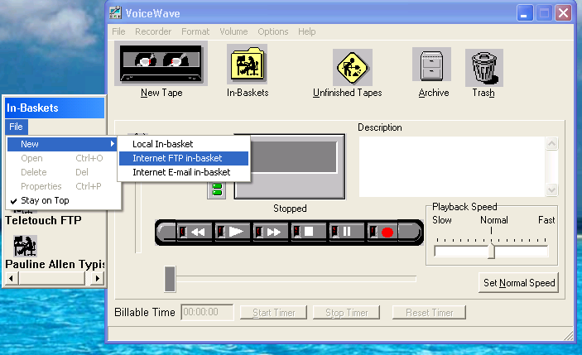

Enter the IP Address in the Host Name and the User ID and Password Assigned.
Note: You will require a local directory as a temporary holding spot for the FTP Files
We recommend you use the / “root” as the Host Directory

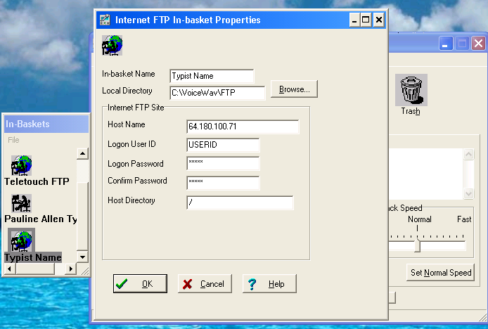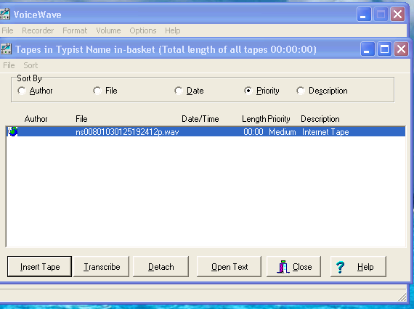

This will allow you access to the FTP with the Voicewave or Converter tools

